Mt. Vernon St.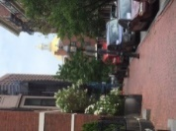 2nd Otis House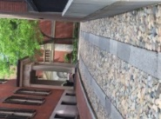
The excerpt following is from a recent CommonWealth Magazine <amiddle@massinc.org> 6.4.17 MassINC | 11 Beacon Street, Suite 500, Boston, MA 02108 THE UPLOAD
We must learn from the Seaport District failures James Aloisi

Salvucci offered the most entertaining insight of the evening, through his telling of what he calls the “St. Francis story.” In the story, God calls on St. Francis in a dream to build a church, and while Francis doesn’t think he’s the best fit for the task, he nevertheless obediently goes about the business of erecting the brick and mortar edifice. When it’s finished, and Francis is at rest, a violent storm passes through and destroys the newly built church. Francis complains to God: “Why did you ask me to build a church only to tear it down?” God’s response: “The Church that you have to build is in the minds and hearts of the people, not in bricks and mortar.”
What does that have to do with city planning? It goes to the heart of the matter: planning is not about building a structure, or one-off projects; it’s about identifying and following civic values. Peter O’Connor made the same, or a related, point recently in Commonwealth when he observed: “If we approached development in a thoughtful, consistent, fair, and transparent way, we’d be asking a different question: Does this proposal meet the criteria for the redevelopment and growth of our city that we have adopted for this site?” Bold is from me
Site Visit Question: Due Oct. 11, 2017; 2 ½-3 pages; 12 point; double spaced. 60 points.
Option One:
Difficult as it is to picture today, the area surrounding Boston Common was an undeveloped outskirt of Boston until the early 19th Century. Yet the recreational potential of this 50 acre parcel in combination with the graceful layout of Mt. Vernon and Beacon Streets with their brick clad, gracefully appointed Federal and Greek Revival style homes, has made this one of the most desirable locations for “the sifted few.” Together with the addition of the grand public building that is the Massachusetts State House, it is easy to understand how this area of field and pasture developed so rapidly into a desirable residential area of Boston. Using details from the visit itself to support your comments explain what you discovered in this neighborhood to make it such a sought after residential location.
Option Two:
Introduction: But those who live here are, of course, the “sifted few.” In many ways this is a nineteenth Century version of a “gated community,” as we discovered in its creation and relationship with the uses of the Common. The manner of its development predicts and is mirrored by development today, moving the hoi polloi out of desirable areas so those with wealth and connections can take them over. It is a story seen again and again in Boston’s history (taking the West End), and in the current development madness (Seaport; West End again; areas around the Common; the Fens, to name a few). We are creating in Boston a dangerous precedent for the future of the city, literally and figuratively, overshadowing important sites and buildings. (For an interesting take on the subject, read the article below).
Despite its loveliness, the South Slope history represents the battle between civic and privilege, rapacious profit mongering and the public trust.
Question: After our visit, what is your take on this subject. Do the beauty and tranquility of this neighborhood stand up against the methods used to develop and maintain it (see second article pasted in)? Or do we need to make public trust a part of our development PLANNING, as the opening quote from St. Francis suggests?
Please Read both brief articles from the Globe.
http://www.bostonglobe.com/business/2017/10/01/windows/l9ZXRHaZJC7ZDfusfEY0DI/story.html?et_rid=1822210513&s_campaign=todaysheadlines:newsletter

Old South Church puts a $19 million price on sunlight

46 Comments Print 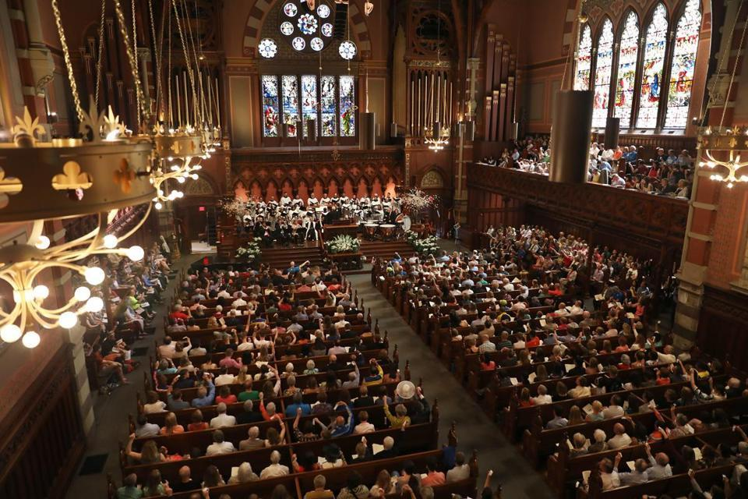Pat Greenhouse/Globe Staff
Old South Church’s leaders hope a developer will be forced to provide more funding for affordable housing programs.
By Tim Logan Globe Staff October 01, 2017
Old South Church has put a price on sunlight: $19 million.

That’s how much the historic Copley Square church wants developer Boston Properties to pay as compensation for shadows a planned tower at Back Bay Station would cast on the 142-year-old church, potentially causing moisture damage to masonry and darkening stained-glass windows.
It’s the latest example of development colliding with city landmarks and the complex interplay of shadows on open spaces.

The request also is an unusual bid to use building shadows as leverage to tackle a broader issue: the high cost of housing in Boston. Of the $19 million Old South Church is seeking, $4 million would go toward repairs to the church itself. The rest, $15 million, would seed a citywide fund for affordable home-ownership programs.
As has been happening at other religious organizations, young families in Old South Church’s congregation are moving out of the city in search of less-expensive housing, senior minister Nancy Taylor said. This is an opportunity to give some of them a better chance to stay, she said.
“This is a crying need in our city,” Taylor wrote recently in a letter to Boston Properties. “Old South Church is prepared to trade what we will lose in aesthetics for $15 million in justice and kindness.”
But to Boston Properties, the asking price is way too steep. The developer plans $72 million in upgrades to the dingy train depot and its surroundings as part of its $1 billion Back Bay Station project that would put three office and apartment towers atop the commuter hub and a neighboring garage over the Massachusetts Turnpike.
It said the request is out of proportion with any damage that shadows from one building 365 feet tall might inflict on the facade of the church two blocks away — such as persistent dampness caused by a lack of sunlight. Boston Properties has hired architects — including a prominent New York firm that specializes in preservation — to study the projected shadows. The finding: It’s unlikely there would be significant damage to Old South Church or to Trinity Church, which is on the edge of Copley Square.
“We just don’t see the science behind it,” said Michael Cantalupa, a senior vice president with Boston Properties. “There’s not $19 million worth of impact here.”
Even in a city where so-called mitigation funds and community amenities are standard for large development projects, $19 million is a big request.
Typically, developers seeking city approvals dole out a few hundred thousand dollars to community groups and to fund parks as a way to curry favor with neighbors. That’s in addition to city-mandated contributions to affordable housing — either through cash payments or by building low-cost units themselves. Boston Properties estimates its affordable housing bill alone will top $23 million for the Back Bay Station project.

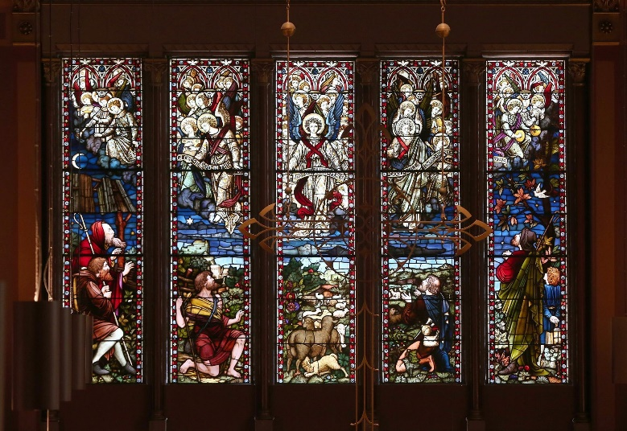 Pat Greenhouse/Globe Staff
Old South Church’s stained glass could be darkened by a planned high-rise at Back Bay Station, church leaders say
Officials with Old South Church and the Greater Boston Interfaith Organization, which is partnering with the church to push for the housing money, acknowledge their request is bold. But they say the costs to maintain the historic church, which is open 24 hours a day and hosts a range of social service and community groups, are substantial and could grow if the extra shadow leads to water damage. They cite a report by the Massachusetts Historical Commission in April that said the shadows would have an “adverse impact” on Old South and Trinity churches, as well as on other nearby historic buildings.
Old South Church would rather head that off altogether and urged Boston Properties to build a shorter building, which the company says isn’t economically feasible. If that’s the case, Taylor said, the church would like to create a fund — run by a housing nonprofit — to help low- and middle-income Bostonians buy homes in the city.
“We’re making a different sort of request for mitigation,” she said. “It was the best thing we could come up with that would really make a difference.”
Earlier this year, another developer’s plans to build a tower sparked debate about the shadows it would cast on Boston Common and the Public Garden. In late July, Governor Charlie Baker signed legislation amending state laws governing such shadows, allowing Millennium Partners to move forward with the project, a more than 700-foot building at the old Winthrop Square parking garage site. Separately, the company agreed to contribute $125,000 annually for 40 years to the Friends of the Public Garden group to help fund improvements to parks.
The Boston Planning & Development Agency has not taken a position on Old South Church’s request for a contribution from Boston Properties. A spokeswoman said it has delayed a vote on the project, initially scheduled for Oct. 12, for at least a month while church officials and the developer keep talking.

“The BPDA will continue to facilitate conversations between Old South Church and Boston Properties to ensure that this project will benefit the surrounding neighborhood and the entire City of Boston,” the agency said in a statement. “We are currently working with the development team on the affordable housing component through the Inclusionary Development Policy.”
That’s the city’s policy governing affordable housing rules for new development. It already requires Boston Properties to include 78 apartments as part of the project itself — or build 90 units nearby — that would be affordable to low- and middle-income renters. Boston Properties plans to meet that obligation, Cantalupa said. But he noted the plans were purposely filed days before more-stringent requirements took effect in January 2016. In part, he said, it couldn’t afford to spend more on affordable housing, given the costly upgrades it has to make to the station and the complexities of building above the turnpike.
“This is already going to be an extremely expensive project,” Cantalupa said.
Asking developers to pay extra for shadows that may not mean much could squelch development in Boston, said Meg Mainzer-Cohen, president of the Back Bay Association, a neighborhood business group. She said Boston Properties’ project fits within recently written zoning and would remake a train station that many people consider an eyesore.
“I think it’s a grossly out-of-whack request and a hijack of $19 million,” Mainzer-Cohen, said. “They’re doing a tremendous disservice to the Back Bay by trying to extort money like this.”
Jean Carroon, a preservation architect at Goody Clancy in Boston who is working on a restoration of Trinity Church — which has similar concerns and supports Old South Church’s request — sees it differently. The churches, she said, along with the Boston Public Library, bring a lot of people to Copley Square. They are part of the fabric of Boston and need to be protected from myriad threats, including water and weeds that can fester in shadows.
“We want these buildings to survive for centuries,” she said. “You can’t hold a city in place but you need to weigh out the impacts.”
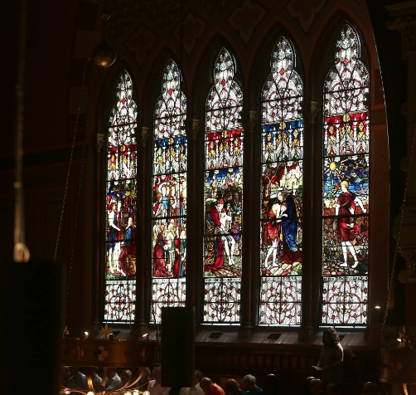 Pat Greenhouse/Globe Staff Tim Logan can be reached at tim.logan@globe.com. Follow him on Twitter @bytimlogan.

BRIAN MCGRORY

Professor vs. tycoon, Part 2
By Brian McGrory, Globe Columnist | February 3, 2010
It’s not easy being Michael Kettenbach these days.
First, his attempts to use his (wife’s) fortune to convert a gorgeous Back Bay condominium building into one of the city’s most glorious single-owner residences have been thwarted by the 82-year-old professor on the fourth floor who has been reluctant to sell the unit where he’s lived for 32 years.
Then a judge came down on Kettenbach like a ton of bricks for leaving the professor, Jerome Wodinsky, and his 67-year-old wife, Bernadette, to negotiate four flights of steep stairs for eight months and counting, while Kettenbach slowly replaces an elevator that he chose to remove. Likewise, the judge didn’t appreciate that Kettenbach unilaterally installed a new heating system for the building, a new electrical system, a new roof, and new skylights, and then told the Wodinskys they owed more than $209,000 for their portion of the work.
And now comes a new setback for Kettenbach and his ham-handed attempts to push the Wodinskys from 303 Commonwealth Ave.: John Walsh.
Readers may remember Walsh. He is the owner and CEO of Elizabeth Grady Cos., a self-made millionaire who grew up in a Somerville housing project, dropped out of college, and emerged as a force in Boston business.
In 2006, Walsh ran into his own housing conflict. When he and his wife tried to buy into a Beacon Hill cooperative building, the bluebloods upstairs looked at him like he was from another planet, telling him in a rejection letter that he “would not reasonably coalesce as a member of this cooperative community.’’ The chairman of that board was Jonathan Winthrop, a descendant of the first governor of the Massachusetts Bay Colony.
The fight, chronicled by my friend and former colleague Steve Bailey, led to a settlement: Winthrop et al. paid Walsh $2.2 million not to live with them.
When I wrote about Jerry and Bernadette Wodinsky a few weeks ago, Walsh immediately e-mailed, asking to meet them. The next day, he climbed all those stairs and offered his help.
“I want to help from a legal, financial, and emotional perspective,’’ Walsh said yesterday. When I asked what that meant, he responded pointedly, “Whatever it takes.’’ The only contingency: Jerry Wodinsky has to quit smoking, which he said he has done.
It gets better. Walsh called it “unconscionable’’ that Wodinsky, who has stents in his legs and respiratory problems, would be forced to constantly negotiate four flights of stairs. Of Kettenbach, he said, “He wouldn’t want someone to do this to his parents.’’
The Wodinskys are, according to their lawyer Don Sweeney, ecstatic to have Walsh’s help. The couple can’t afford the Kettenbachs’ champagne tastes - or years of legal fees. He still teaches at Brandeis; she works in a department store credit department.
For Kettenbach, money came easier. He married into the Demoulas supermarket family.
He and his wife, Frances, bought their first unit at 303 Commonwealth Ave. in 1996. They have since bought three more units - one from a longtime owner who testified that she felt forced to sell. As 80 percent owners of the building, they control all decisions, and seemed eager to use their deep pockets to bully the Wodinskys out of the 2,000-square-foot condo they’ve lived in since the 1970s.
Walsh said yesterday that he would encourage a settlement.
“Mr. Kettenbach has to have a good place in his heart,’’ Walsh said. “I ask that he come forward, pay the fair value, own the whole building, and put this behind him.’’
Kettenbach responded to me with an e-mailed statement yesterday saying, “We have never wanted to fight with our neighbors, the Wodinskys. Nor will we seek to settle this matter through the pages of the Boston Globe.’’
He can settle it wherever he wants. Just end this absurdity before an old man falls down the stairs.
Brian McGrory is a Globe columnist. He can be reached at mcgrory@globe.com.

